**The Ark Documentation.**

**Study Components module.**

Log in and select your study by clicking the hyperlink corresponding to the name of your study.

Once you have chosen your study we will be able to adjust study details or select modules and functions available in that study (for which you have privileges).

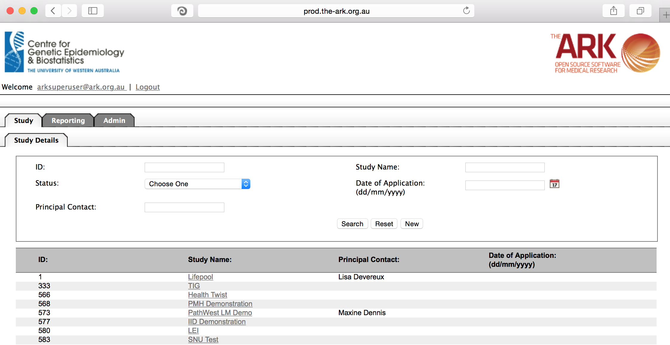

Alternatively if you have a very long list of studies under your management you may use the search pallette/panel at the top of the page. You can search/filter by id, name, principal contact, status of the study or date of application. Once you have added your filtering criteria, click the search button;

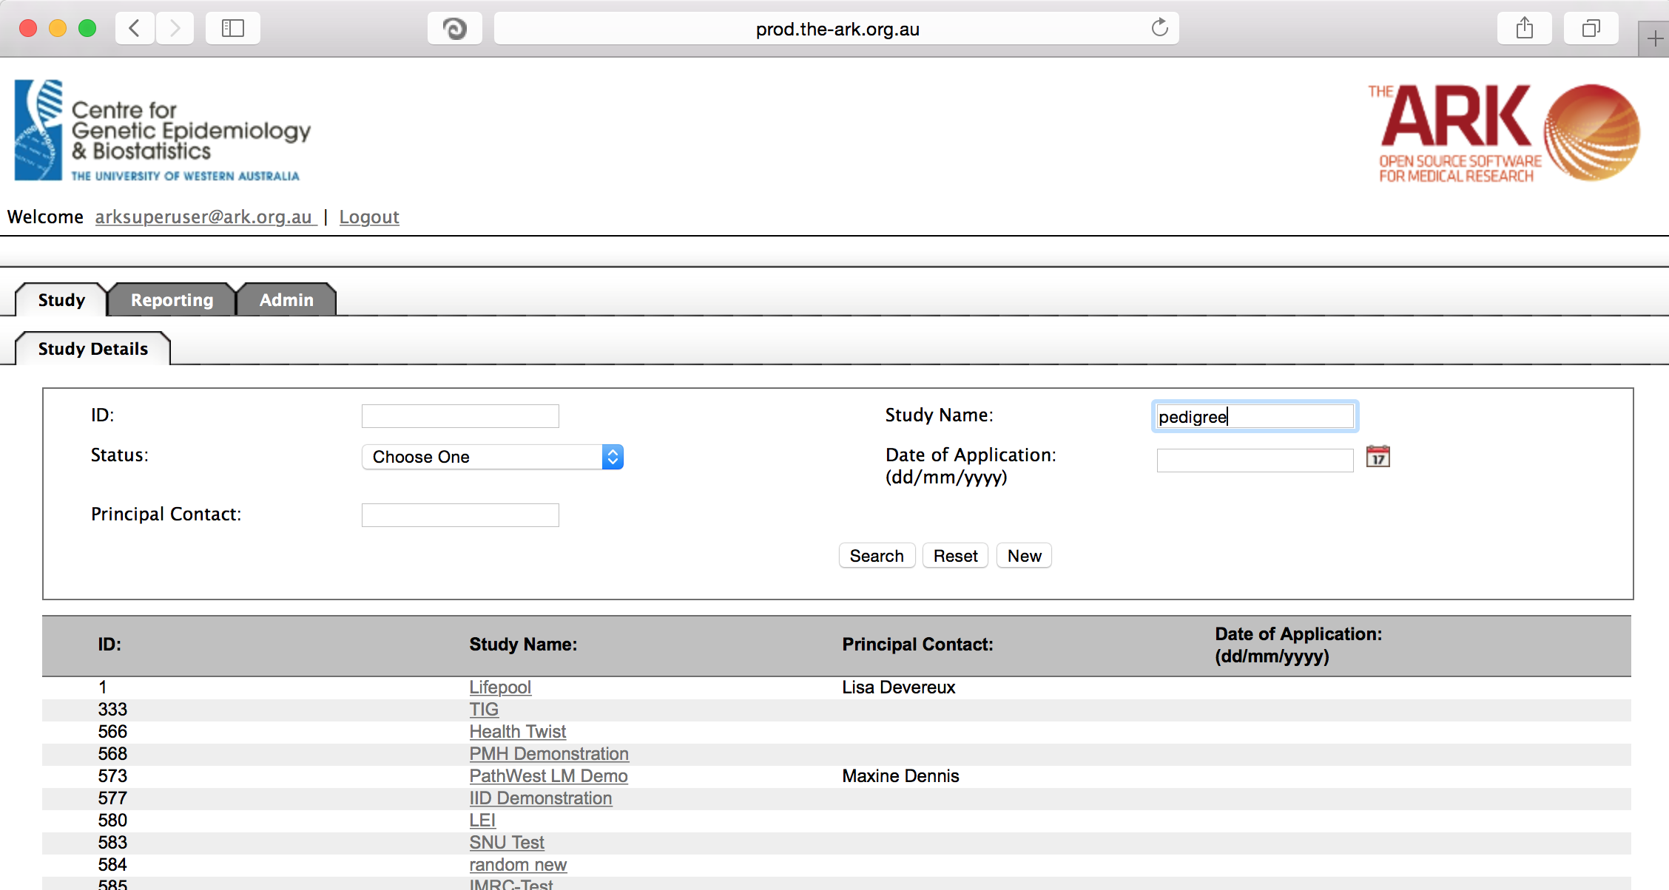

As you can see the filter has helped us find our chosen study and we can click the hyperlinked study name as discussed before;

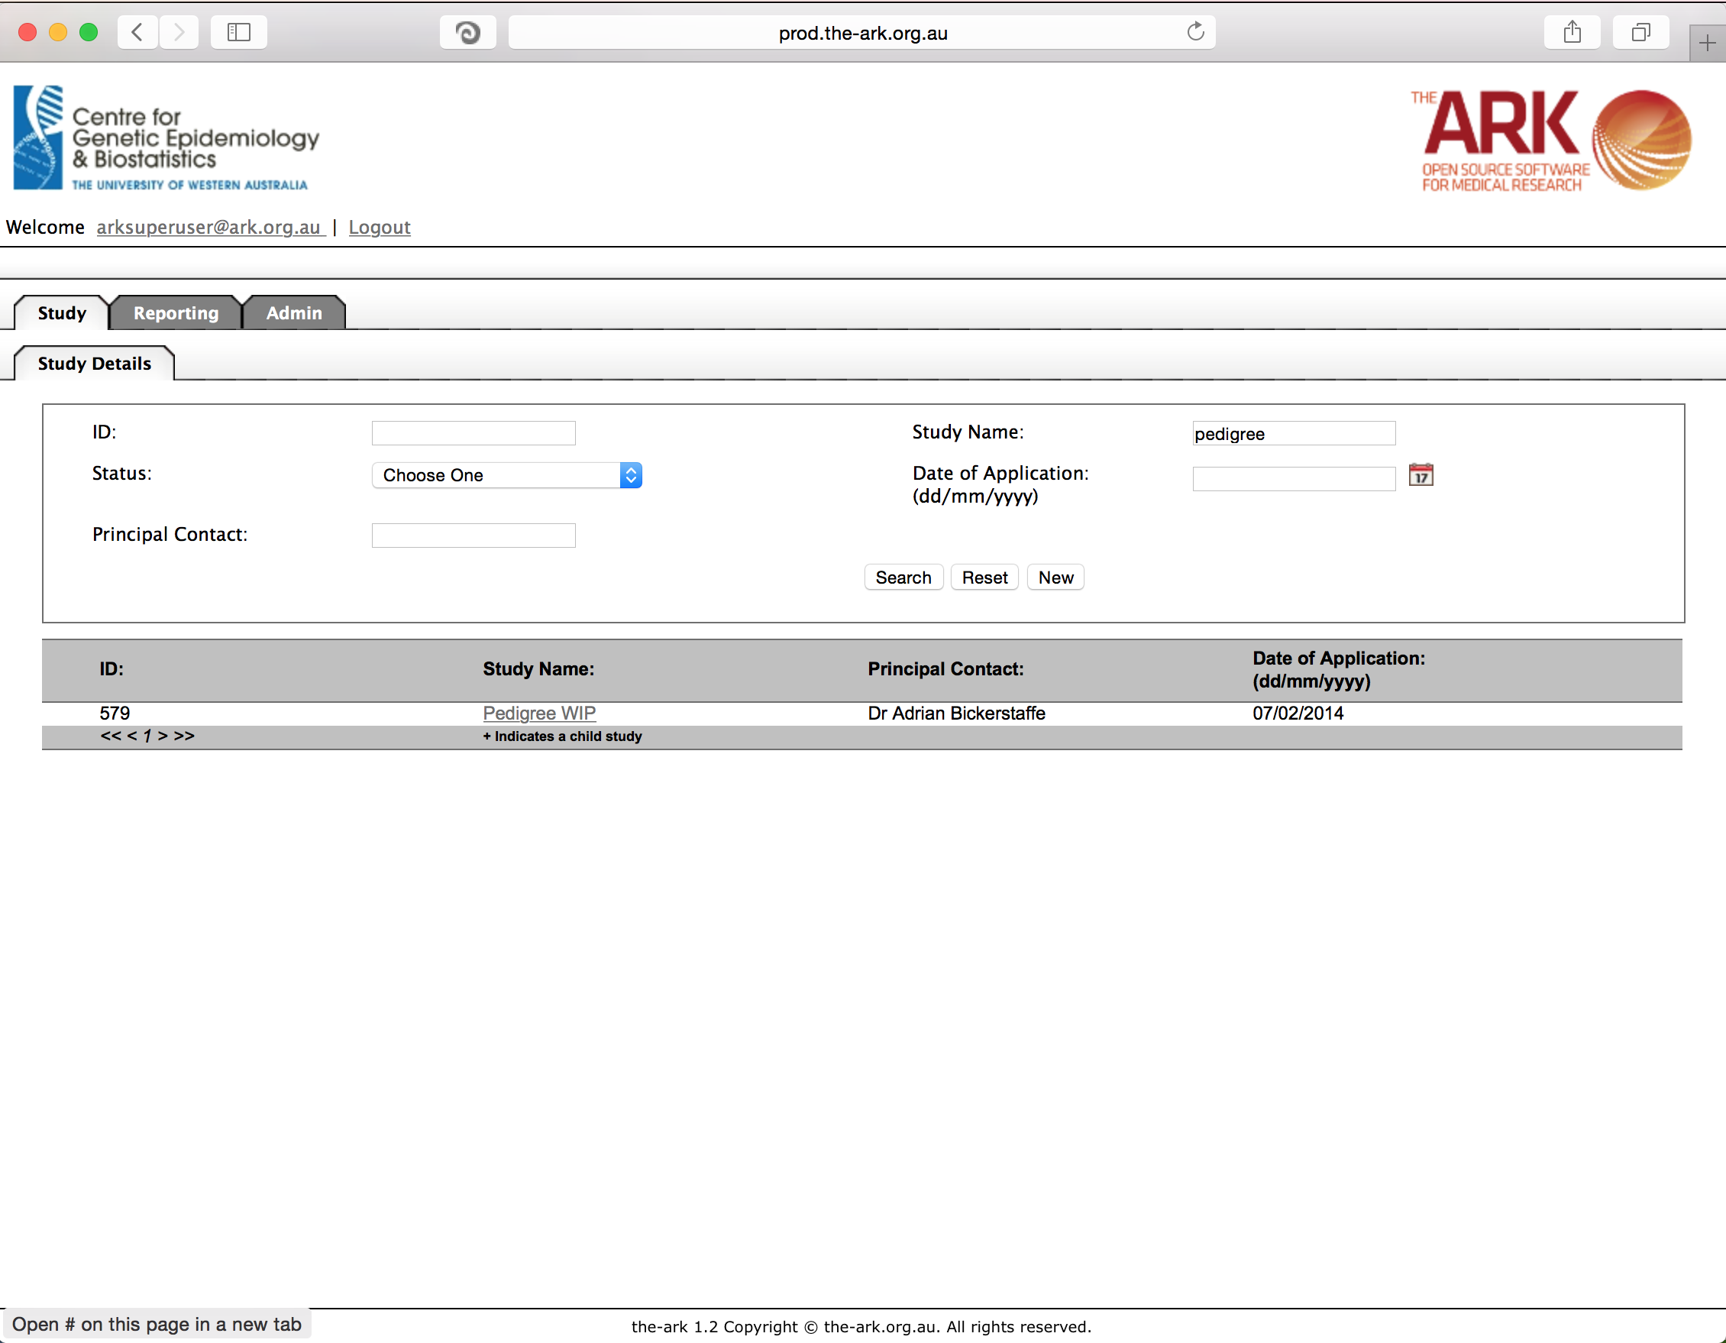

Once you have chosen your study we will be able to adjust study details or select modules and functions available in that study (for which you have privileges). The module we wish to select is Study Components.

Study components allow individual to consent to separate components of a study individually, which can be useful in participation management and selection of subjects for future studies. This separation of study components can also be useful down the line for sorting various correspondences also.

As you can see, the study below has physical blood collection and physical examination as two separate components.

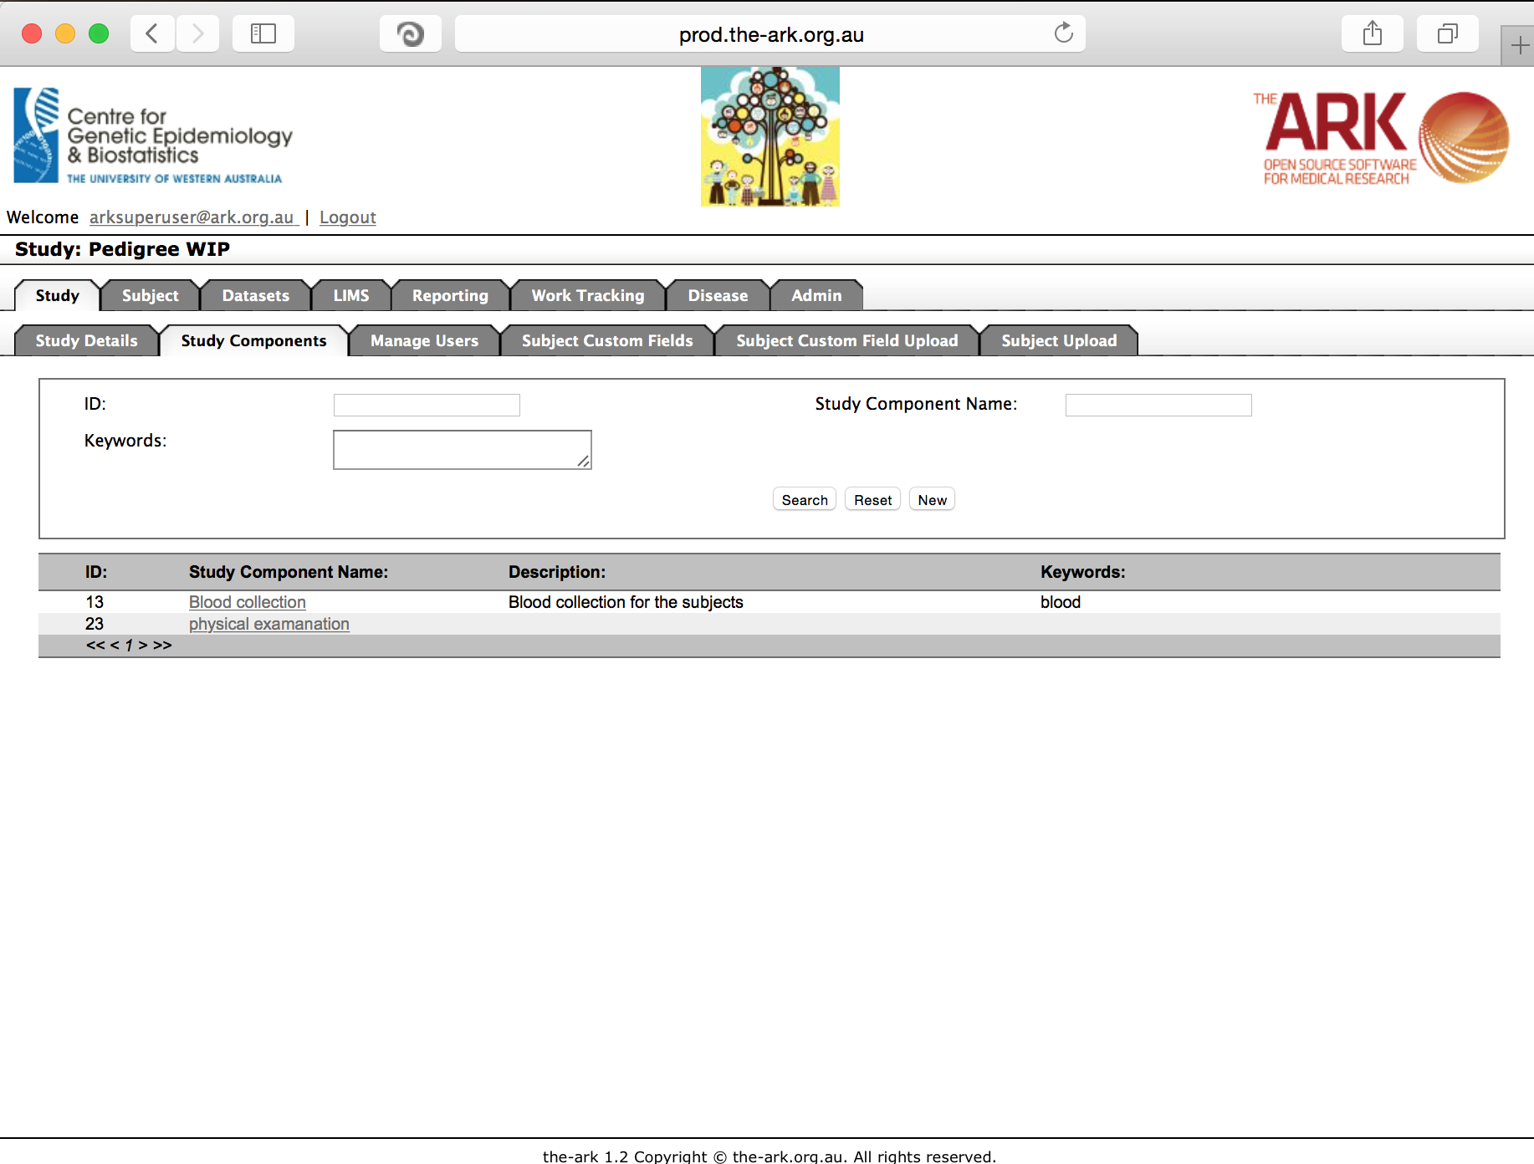

We will now add a 3rd component called publicity followups, for example some studies ask their participants to take part in promotion of their study, newspaper interviews, etc.

Start by clicking the new button. The following will appear;

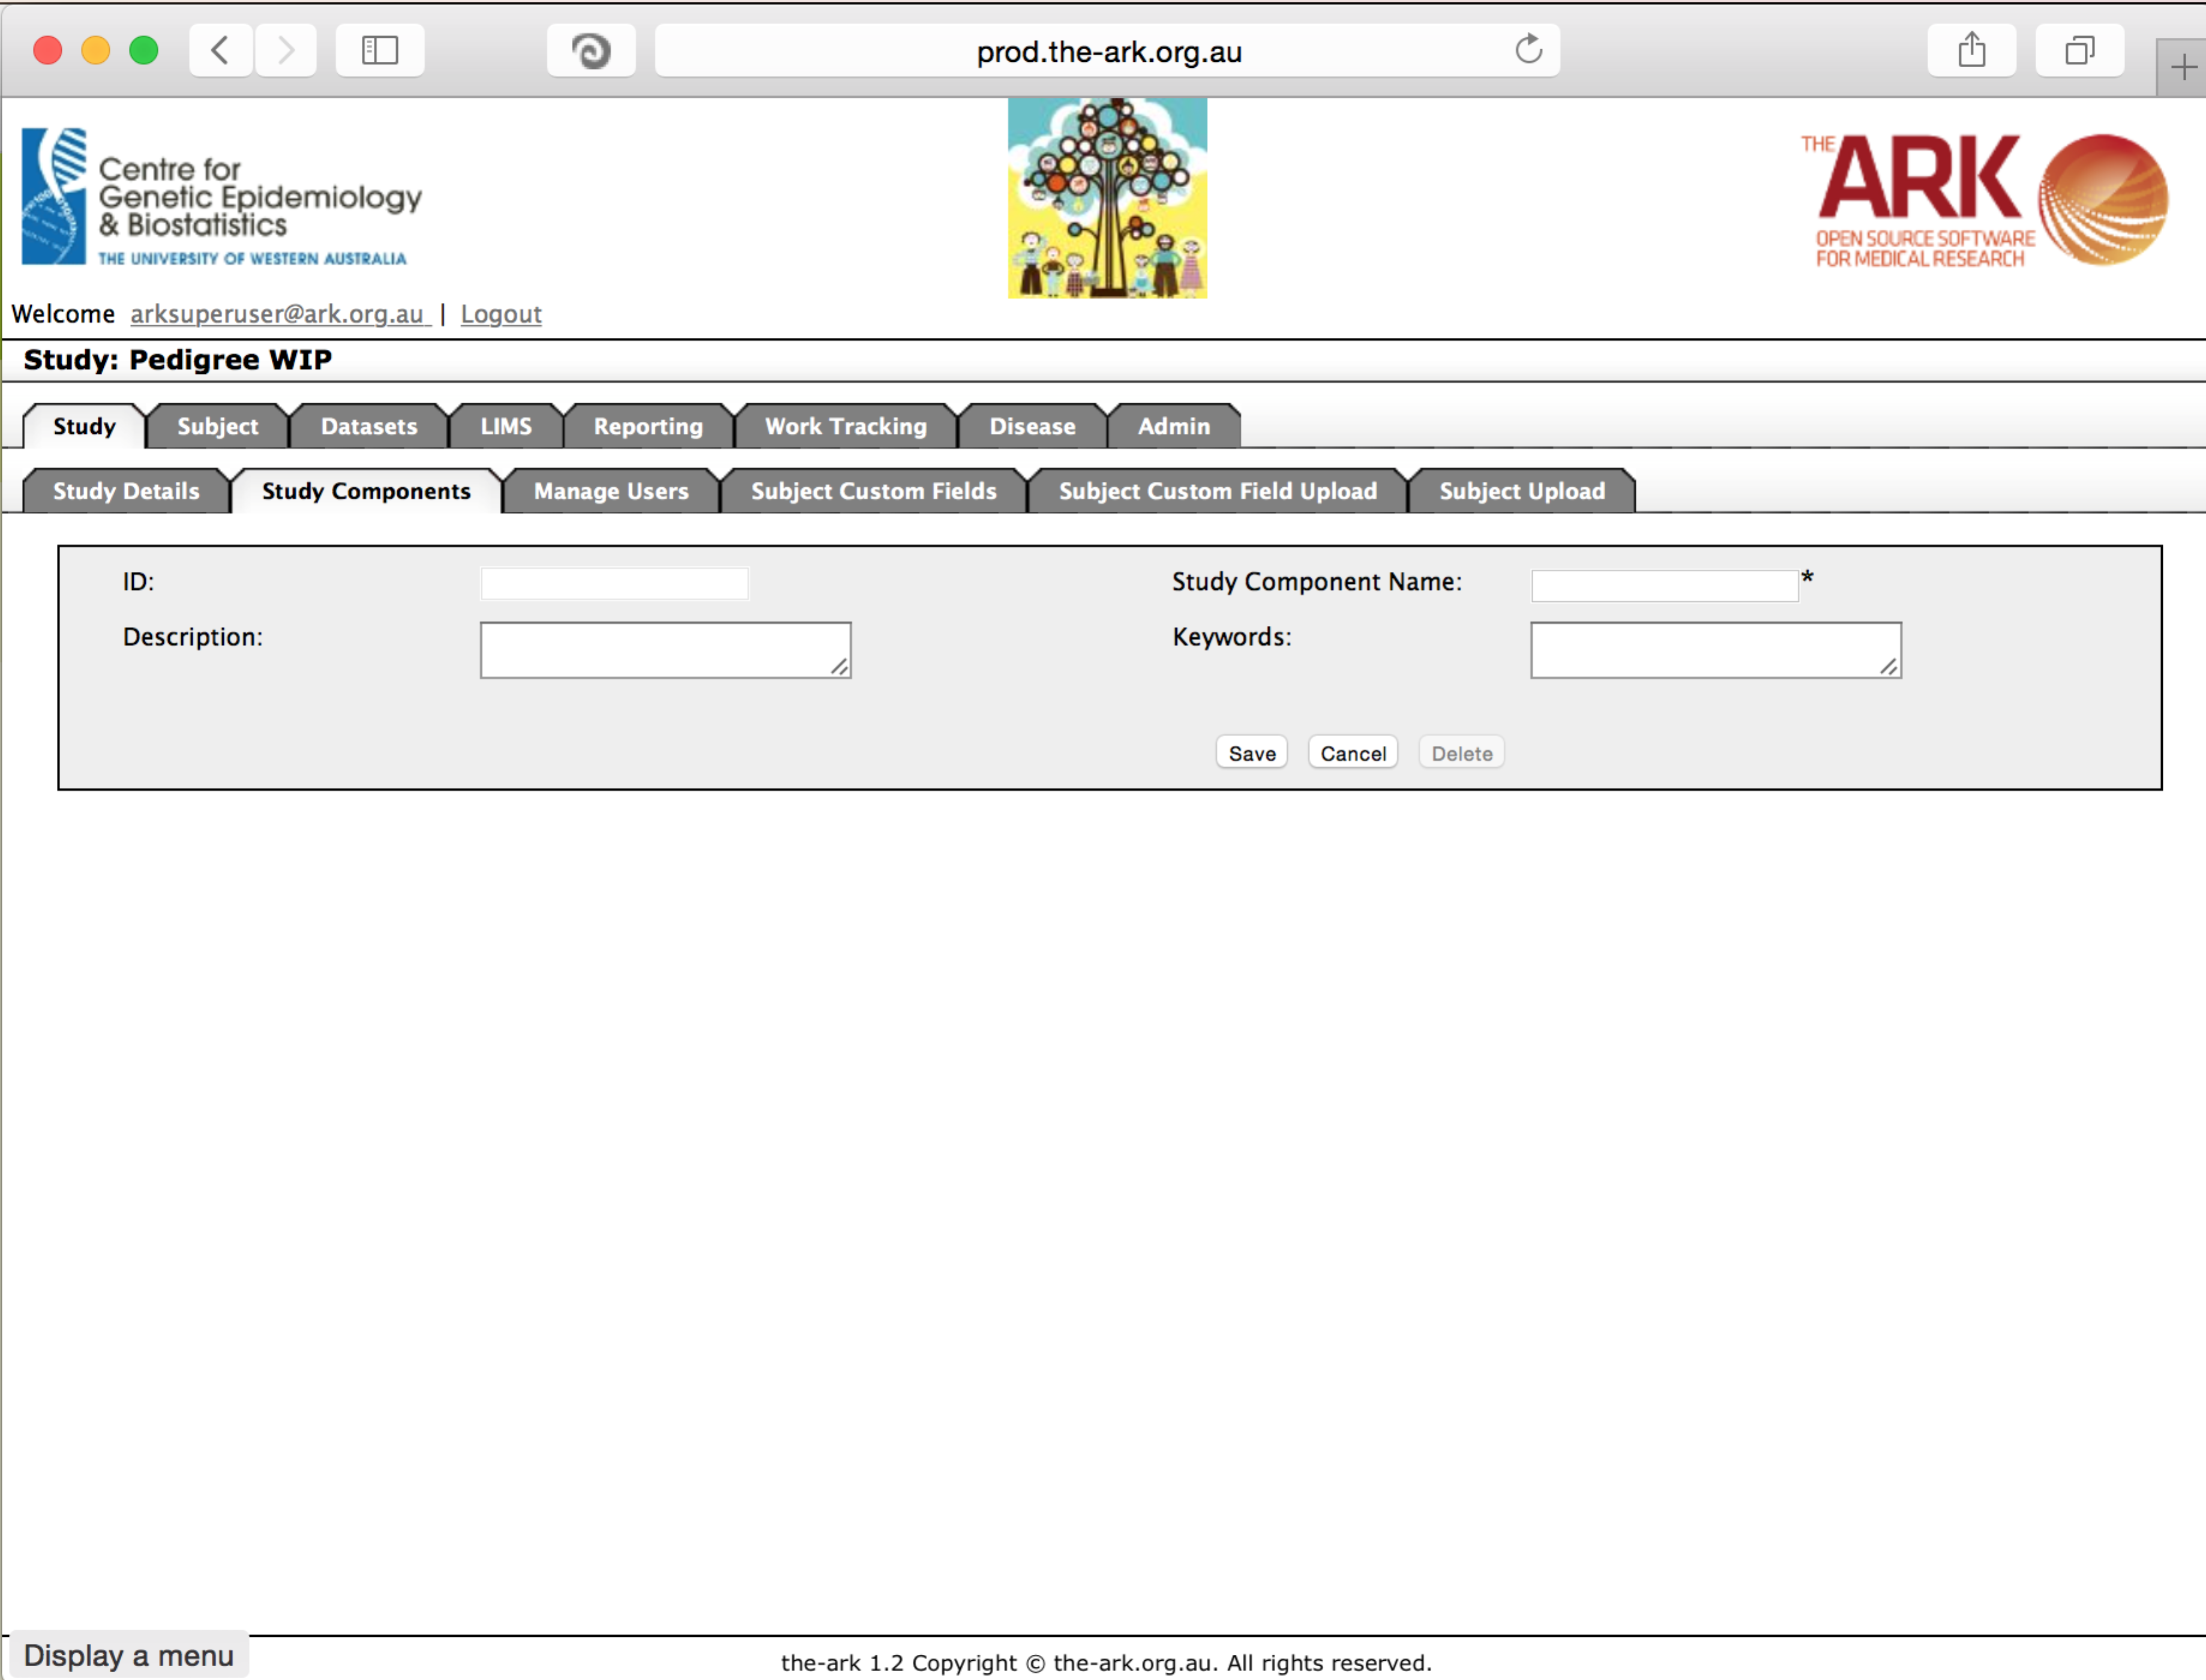The fields are all self-explanatory and will be searchable. So if you might have many separate components, put as much good information in as possible.

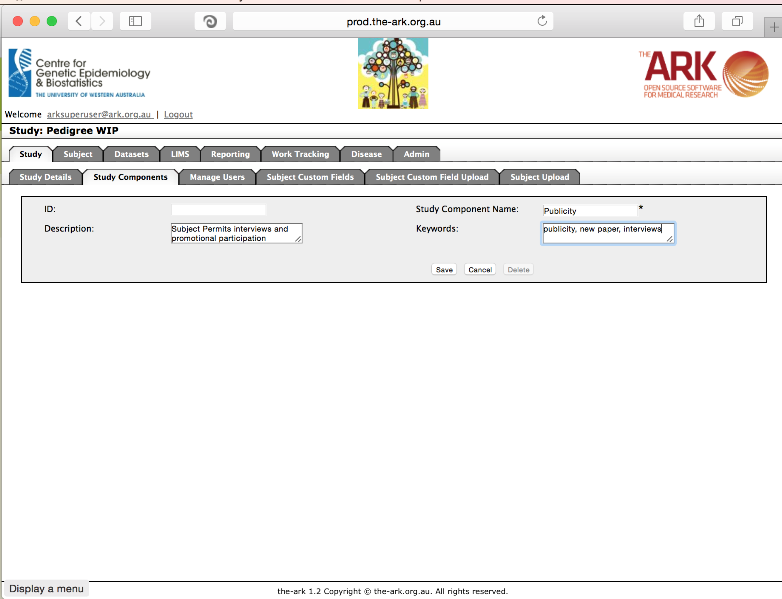

Then click save;

If you have no issues and it has correctly saved, the you will have a green message at the top of the page telling you so. If there were any issues (rare on this page), a message will show up in red describing what you have done wrong.

